How Do NHL Team Defensive Systems Influence Traditional Goalie Statistics?
Lana Robison
STA 43C8 Capstone Project
May 8, 2026

Abstract
This project examines how NHL team defensive systems influence traditional goalie statistics, with save percentage used as the primary response variable. Goalie performance is difficult to evaluate because traditional statistics are affected by both individual goalie ability and the defensive environment in front of the goalie. Data from MoneyPuck and NHL Edge were combined for the 2008-09 through 2024-25 NHL seasons, producing a final dataset of 1,230 goalie-team-season observations and 151 variables. The analysis used exploratory data analysis, multiple linear regression, lasso regression, principal component regression, ridge regression, model diagnostics, and train/test validation. The lasso-informed regression explained a moderate amount of variation in save percentage, with an R² of 0.472 and adjusted R² of 0.460. Principal component regression produced a similar fit while addressing multicollinearity among defensive predictors. Overall, the results suggest that team defensive context is meaningfully related to goalie save percentage, but it does not fully explain goalie performance. Traditional goalie statistics should therefore be interpreted with team context rather than as purely individual measures.
Introduction
Research Question and Motivation
The main research question for this project is: How do NHL team defensive systems influence traditional goalie statistics? More specifically, this project asks how team defensive metrics such as expected goals against, high-danger chances allowed, shots against, and related defensive measures explain variation in goalie save percentage. I chose this topic because I have been a lifelong fan of hockey, especially the Los Angeles Kings, and I have always been fascinated by goalies. Goalies are one of the most important positions in hockey, but they are also one of the hardest positions to analyze quantitatively. A goalie’s performance depends not only on individual skill, but also on the team structure in front of them. Some goalies play behind teams that limit high-danger chances, while others face more difficult shots, more rebounds, or more extended defensive-zone pressure.
This creates a problem when goalies are evaluated mainly by traditional statistics. Save percentage, goals against average, and wins are often discussed as if they belong only to the goalie. However, a goalie on a strong defensive team may look better statistically, while a goalie on a weaker defensive team may be blamed for results that are partly caused by the system around them. The purpose of this project is to quantify how much of a goalie's performance is related to the team's defensive environment. Many great goalies around the NHL can be unfairly judged, either positively or negatively, because of the performance of the team in front of them. This project aims to quantify how much of a goalie’s performance is related to individual play and how much is related to the team’s defensive environment.

Brief Literature Context
This project is motivated by the broader idea in sports analytics that player statistics should be interpreted in context. In hockey, traditional goalie statistics are easy to understand, but they do not fully describe the difficulty of the goalie’s workload. Modern hockey analytics uses measures such as expected goals, shot attempts, unblocked shot attempts, high-danger shots, and rebounds to better understand team and player performance. MoneyPuck provides advanced hockey statistics that measure both shot volume and shot quality. NHL Edge provides traditional goalie statistics that are commonly used in public evaluation. By combining these sources, this project connects modern defensive-context variables with traditional goalie outcomes.
The statistical methods also connect to concepts from Regression Analysis and Sports Analytics II. Regression analysis allows the response variable, save percentage, to be modeled using several predictor variables at the same time. Sports Analytics II provides the data cleaning and modeling workflow, especially through tidyverse data wrangling, string cleaning, tidymodels recipes, and regularized regression.
Overview of Dataset
The final dataset combines MoneyPuck goalie data, MoneyPuck team data, and NHL Edge goalie data from the 2008-09 through 2024-25 NHL seasons. Each row represents a goalie-team-season observation. This means that if a goalie played for different teams or appeared in multiple seasons, those are treated as separate observations. The final cleaned dataset contains 1,230 observations and 151 variables. The primary response variable is sv_percent (save percentage). The main predictors are team defensive variables, including expected goals against, shots on goal against, shot attempts against, rebounds against, high-danger shots against, Corsi percentage, Fenwick percentage, giveaways, penalties, and workload variables.
Methods
Description of Dataset and Variables
The response variable for the main analysis is sv_percent (save percentage). Save percentage was chosen because it is one of the most common traditional goalie statistics and directly measures the proportion of shots on goal saved by a goalie. Although it is a goalie statistic, it can still be influenced by team defense because not all shots are equally difficult to save. The predictor variables were selected to represent different parts of team defensive context. These variables include:
- team strength and puck possession variables: “team_corsi_percentage”, “team_fenwick_percentage”, “team_x_goals_percentage”
- shot volume variables: “team_shots_on_goal_against_pg,” “team_unblocked_shot_attempts_against_pg”
- chance quality variables: “team_high_danger_shots_against_pg,” “team_high_dangerx_goals_against_pg”
- context variables: rebounds, giveaways, penalties, games played, games started, time on ice.
Many team totals were converted into per-game rates. This made the variables more comparable across teams and seasons, especially because not every NHL season in the dataset had the exact same number of games.
Data Cleaning and Preparation Steps
The data cleaning process began by loading separate MoneyPuck goalie data, MoneyPuck team data, and NHL Edge goalie data. Since the data came from different sources, player names, team abbreviations, and season formats had to be standardized before joining the datasets.
Team names were cleaned so that abbreviations were consistent across data sources. For example, LA and L.A were standardized to LAK, NJ and N.J were standardized to NJD, SJ and S.J were standardized to SJS, and TB and T.B were standardized to TBL. Seasons were coded using the starting year of the NHL season, so the 2008-09 season is referred to as the 2008 season.
The MoneyPuck goalie and team data were filtered to the “all” situation. The team-level variables were renamed with a team_ prefix so that they could be separated from goalie-level variables after joining. The datasets were then joined by player, team, and season where appropriate.
Players with very small samples were removed by requiring goalies to appear in more than 8% of their team’s games in a season. This helped remove observations that were too small to represent meaningful goalie-season performance while still allowing shortened seasons to remain in the dataset. Observations with missing key response variables, such as save percentage and goals against average, were also removed.
Statistical Methods Employed
The analysis used several statistical methods. Exploratory data analysis was used to summarize save percentage, goals against average, team defensive variables, league trends, and correlations between variables. Multiple linear regression was then used to model save percentage as a function of team defensive and workload variables. In this model, save percentage is the response variable and the defensive statistics are the predictor variables.
Lasso regression was used for variable selection. Lasso shrinks weaker coefficients toward zero and can set some coefficients exactly equal to zero. This helped reduce the broad predictor set into a smaller group of selected variables. After lasso selected variables, a lasso-informed ordinary least squares regression model was fit using those retained predictors. This kept the model interpretable because the predictors remained in the original hockey variable space.
Principal component regression was also used to address multicollinearity. PCA transforms correlated predictors into uncorrelated principal components, and PCR then uses those components in a regression model. Ridge regression was included as an additional regularized regression benchmark. Finally, model diagnostics and validation were used to evaluate regression assumptions, multicollinearity, and test-set performance.
Justification for Methodological Choices
Multiple regression was appropriate because the research question asks how several defensive variables relate to save percentage at the same time. A simple comparison of one variable to save percentage would not be enough because hockey defensive systems are made up of several connected factors. Lasso provided a data-driven way to select a smaller group of predictors. Principal component regression was used because many team defensive metrics measure similar parts of the game, creating multicollinearity. PCR was included as a way to compare the interpretable lasso-informed model with a model designed to handle correlated predictors. The train/test split and cross-validation were used to evaluate whether the models generalize beyond the data used to fit them. This is important because a model can fit the training data well but perform poorly on new observations.
Software and Packages Used
All analysis was done in R and packages used were: tidyverse, tidymodels, broom, GGally, car, ggcorrplot, ggplot2, janitor, readxl, and stringr.
Results
Exploratory Data Analysis Findings
The final dataset contained 1,230 goalie-team-season observations. Save percentage was tightly clustered, with a mean of 0.9073 and a median of 0.9090. The minimum save percentage was 0.836 and the maximum was 0.954. This shows that most NHL goalies fall within a narrow range, so even small differences in save percentage can be meaningful.
League-average save percentage and GAA changed across seasons. This suggests that goalie statistics should be interpreted within the season and league environment in which they occurred. A save percentage that is strong in one season may not be equally strong in another if scoring levels have changed.
The EDA also showed that team defensive environments vary across observations. Team expected goals against, high-danger shots against, and Corsi percentage all differed across teams and seasons. Scatterplots suggested that save percentage is related to team defensive environment, although the relationships were not perfectly linear or deterministic.
Results from Primary Statistical Analyses
The lasso model selected a penalty value of 0.0000187 and retained 21 predictors. The selected variables included team Corsi percentage, team goals for per game, shots on goal against per game, unblocked shot attempts against per game, rebounds against per game, freeze against per game, play continuation variables, giveaways, defensive-zone giveaways, penalty minutes, low-danger shots against, high-danger shots against, low-danger expected goals against, high-danger expected goals against, games played, games started, and time on ice.
This result suggests that save percentage is related to several parts of the team defensive environment rather than one single variable. Shot volume, chance quality, rebounds, turnovers, and workload all appeared in the selected model.
The lasso-informed ordinary least squares regression produced the following model fit:
Model | R² | Adjusted R² | Sigma | Overall p-value
Lasso | 0.472 | 0.460 | 0.0107 | 8.99e-110

The model explained about 47.2% of the variation in save percentage in the training data. This is a moderate amount of variation, which makes sense because goalie save percentage is affected by both team context and individual goalie performance.
Several predictors were statistically significant in the lasso-informed model. For example, team_shots_on_goal_against_pg, team_unblocked_shot_attempts_against_pg, team_rebounds_against_pg, team_freeze_against_pg, and team_play_continued_in_zone_against_pg were all statistically significant. However, because many of these variables are highly correlated, individual coefficient signs should be interpreted cautiously.
Principal component regression selected 27 principal components. Its model fit was very similar to the lasso-informed regression:
Model | R² | Adjusted R² | Sigma | Overall p-value
PCR | 0.473 | 0.457 | 0.0108 | 1.22e-105

PCR had nearly the same explanatory power as the lasso-informed model, but it handled multicollinearity better because principal components are uncorrelated.

Tables and Figures
Table 1. Summary of Save Percentage and Goals Against Average
Statistic | Save Percentage | GAA
Minimum | 0.836 | 1.220
1st Quartile | 0.899 | 2.450
Median | 0.909 | 2.730
Mean | 0.9073 | 2.787
3rd Quartile | 0.917 | 3.070
Maximum | 0.954 | 4.710

Table 2. Model Comparison on the Test Set
Model | Test RMSE | Test R² | Test MAE
PCR | 0.0121 | 0.411 | 0.00797
Lasso | 0.0121 | 0.408 | 0.00795
Lasso (Penalized) | 0.0121 | 0.409 | 0.00786
Ridge | 0.0128 | 0.361 | 0.00842

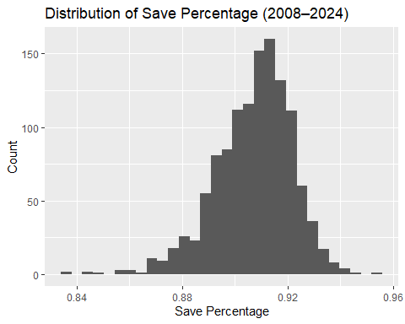
Figure 1. Distribution of Save Percentage
Save percentage is tightly clustered around 0.907, showing that most NHL goalies perform within a narrow range.

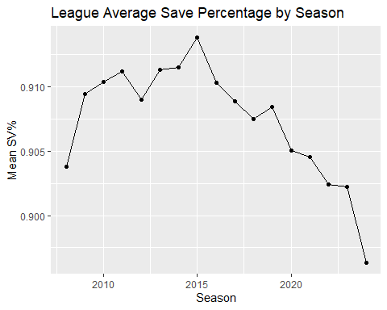
Figure 2. League Average Save Percentage by Season
League-average save percentage changes over time, so goalie performance should be interpreted within the season context.
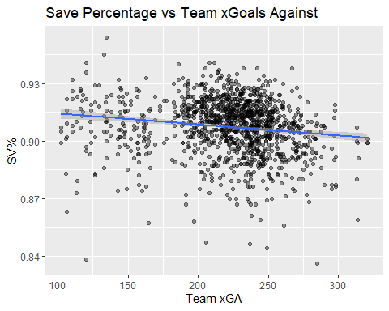
Figure 3. Save Percentage vs. Team Expected Goals Against
The scatterplot suggests that team defensive environment is related to goalie save percentage, but the relationship is not perfectly deterministic.
Figure 4. Correlation Matrix of Goalie Performance and Team Defense
Several team defensive variables are correlated with one another, showing multicollinearity.
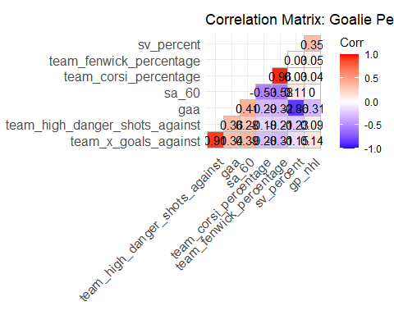

Figure 5. Lasso Tuning Plot
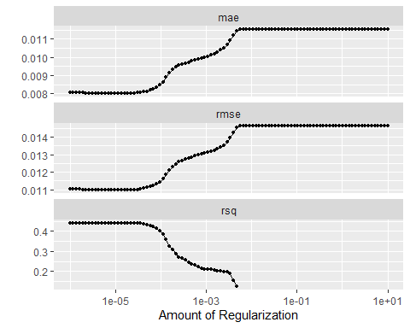
Cross-validation was used to select the lasso penalty value that minimized RMSE.

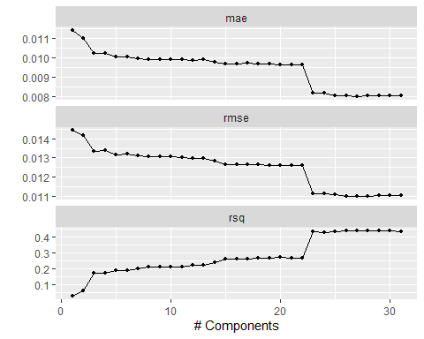
Figure 6. PCR Tuning Plot
Cross-validation selected 27 principal components for the principal component regression model.

Model Diagnostics and Validation
The lasso-informed regression model had strong overall fit, but the VIF results showed substantial multicollinearity. Several predictors had VIF values far above common thresholds. For example, toi_min, team_unblocked_shot_attempts_against_pg, gs, and gp_nhl all had very large VIF values. This means the lasso-informed model is useful for overall prediction and explanation, but individual coefficients should not be overinterpreted.
This multicollinearity also makes sense in hockey terms. Team defensive variables are connected. A team that allows many unblocked shot attempts will often also allow more shots on goal, expected goals, rebounds, and high-danger chances. These variables are not isolated from one another because they are all part of a broader defensive system.
Principal component regression solved the multicollinearity problem because all VIF values for the principal components were equal to 1. This made PCR more stable statistically, although less directly interpretable because the predictors were components rather than original hockey statistics.
The test-set validation showed that PCR, lasso-selected regression, and penalized lasso performed very similarly. All three had RMSE values around 0.0121 save percentage units. Ridge regression performed slightly worse, with an RMSE of 0.0128. These results suggest that the main conclusion is not dependent on a single model. Across several modeling approaches, team defensive variables contained meaningful information about goalie save percentage.

Discussion
Interpretation of Results in Context
The main finding is that team defensive context is meaningfully related to goalie save percentage. The models explained a moderate amount of variation in save percentage, which supports the idea that goalies should not be evaluated using traditional statistics alone. At the same time, the models did not explain all variation in save percentage. This is important because goalie performance is still partly individual. A goalie’s skill, positioning, rebound control, athletic ability, health, workload, and consistency all matter. The results suggest that save percentage is both an individual and contextual statistic. The lasso-selected variables also make sense from a hockey perspective. The model retained variables related to puck possession, shot volume, rebounds, play stoppages, high-danger shots, giveaways, penalty minutes, and workload. This supports the idea that defensive systems influence goalies in several ways, not just through total shots allowed.
Comparison with Existing Literature
This project is consistent with the general idea in hockey analytics that expected goals, shot quality, and shot volume provide more context than traditional statistics alone. Traditional statistics such as save percentage and GAA are useful, but they do not fully describe the difficulty of the shots a goalie faces. MoneyPuck’s advanced metrics are designed to add this type of context by using expected goals and shot-quality information. NHL Edge provides traditional goalie statistics that are commonly used by fans, media, and analysts. Combining these two types of data supports a more complete evaluation of goalie performance. The results also connect to the regression and sports analytics course material. The regression results show why multiple regression is useful for estimating relationships while holding other variables constant. The multicollinearity results also show why diagnostics are necessary. Without checking VIF values, it would be easy to overinterpret individual coefficients from the lasso-informed model.
Limitations and Assumptions
The biggest limitation is that the data are observational. Goalies are not randomly assigned to teams or defensive systems. Therefore, the results should be interpreted as associations, not causal effects. The models can show that team defensive variables are related to save percentage, but they cannot prove that changing one defensive variable would directly cause a specific change in goalie performance.
Another limitation is multicollinearity. Many team defensive variables measure overlapping parts of defensive play. This makes coefficient-level interpretation difficult. PCR addressed this issue statistically, but PCR is less interpretable because the model uses principal components rather than the original hockey variables.
A third limitation is that goalies appear across multiple seasons. This means the observations are not perfectly independent. A mixed effects model with goalie as a random effect would be a strong future improvement because it could better separate goalie-level variation from team-level context.
The final models also did not fully account for season or era effects. The EDA showed that league-average save percentage and GAA changed over time, so future models could include season indicators or era indicators. Finally, save percentage is only one measure of goalie performance. Future analysis could also use goals saved above expected, danger-level save percentage, or five-on-five-only statistics.
Ethical Considerations
There are ethical concerns with using statistical models in player evaluation because these models can affect trades, contracts, and public reputation. Hockey in the NHL is ultimately a business, but players are still people whose careers can be shaped by how teams interpret performance data. One ethical concern is overconfidence. A model like this should not be used to label a goalie as good, bad, or system-dependent without acknowledging uncertainty. The model does not capture every factor that affects performance, such as injuries, coaching, communication with defensemen, mental pressure, or team tactics. Another concern is fairness. A goalie with poor traditional statistics may have played behind a weak defensive team and faced more difficult chances. On the other hand, a goalie with strong traditional statistics may have benefited from a strong defensive structure. Using context can make evaluation more fair, but only if the model is communicated honestly. For trades, this matters because teams should be careful when projecting a goalie into a new system. A goalie who succeeds behind one defensive structure may not perform the same way elsewhere. Similarly, a goalie with average traditional numbers may be undervalued if their team context was difficult.
Future Directions
A natural future direction is a mixed effects model with goalie as a random effect. This would account for repeated observations from the same goalie across multiple seasons and could help separate goalie skill from team defensive context. Future work could also include season effects, era comparisons, five-on-five-only data, penalty-kill context, defensive pairings, rest, back-to-back games, coaching changes, and player tracking variables.

Conclusions
Summary of Key Findings
This project found that NHL team defensive systems are meaningfully related to traditional goalie performance statistics, especially save percentage. The lasso-informed regression explained a moderate amount of variation in save percentage, with an R² of 0.472 and adjusted R² of 0.460. PCR produced a similar model fit while addressing multicollinearity. On the test set, PCR, lasso-selected regression, and penalized lasso all performed similarly, with RMSE values around 0.0121.
The results suggest that save percentage is not purely an individual goalie statistic. It is partly shaped by the defensive environment in front of the goalie, including shot volume, chance quality, rebounds, turnovers, and workload. However, team context does not explain everything, which means individual goalie variation still matters.
Broader Implications
The broader implication is that goalie evaluation should be contextual. Fans, analysts, and teams should be careful when using traditional statistics alone to judge goalie performance. A goalie’s numbers should be interpreted alongside the type of defensive system they played behind. This is especially important for trades and contracts. A team should not assume that a goalie’s save percentage will automatically transfer to a new team environment. Instead, teams should consider whether the goalie’s past performance was supported by the defensive structure in front of them. Overall, this project supports a more balanced approach to goalie evaluation. Traditional statistics are still useful, but they are more meaningful when combined with team defensive context.
References
MoneyPuck. (n.d.). NHL goalie advanced statistics. MoneyPuck.com.
MoneyPuck. (n.d.). NHL team advanced statistics. MoneyPuck.com.
National Hockey League. (n.d.). NHL EDGE goalie statistics. NHL.com.
STA 2300 Intro to Data Science course notes.
STA 3311 Sports Analytics II course notes.
STA 3386 Regression Analysis course notes.

Appendix
The following are attached in separate documents:
Appendix A: Data Dictionary
Appendix B: Reproducible Code
B.1. Data Cleaning
B.2. Exploratory Data Analysis
B.3. Statistical Analysis Output

